**MRP SharePoint Site**

Major Research Project – Big Data Analytics Program

Author: Chris Dyck

Review by Brunilda Xhaferllari @13/02/2022

# Table of Content

Table of Content 2

001 SharePoint Task Lists App for Project Management 3

SharePoint Set up the Task List 3

002 Software Development Lifecycle (SDLC) 5

SharePoint Task List - SDCL Timelines Add Tasks 5

003 Microsoft Project 8

SharePoint Task List - Integrate Microsoft Project 8

004 Microsoft Outlook 9

SharePoint Task List - Connect Microsoft Outlook 9

005 SharePoint Lists App for Timesheets 10

SharePoint Setup Timesheets List 10

006 SharePoint Lists App for Timesheets 14

SharePoint Create View 14

007 SharePoint Issue Tracker App for Action Items 16

SharePoint Action Items 16

008.01 Minutes of Meeting 18

SharePoint Minutes of Meeting (MOM) 18

008.02 SharePoint List App for Minutes of Meetings 19

SharePoint Setup Minutes of Meeting 19

009.00 SharePoint Excel Dashboard 25

SharePoint Setup Dashboard 25

010.00 SharePoint Project Dashboard Page 26

SharePoint Setup Project Dashboard Page 26

# 001 SharePoint Task Lists App for Project Management

## SharePoint Set up the Task List

The Task List App will allow you to manage tasks assigned to team members and allow you to demonstrate the number of the hours allotted to you in the project.

[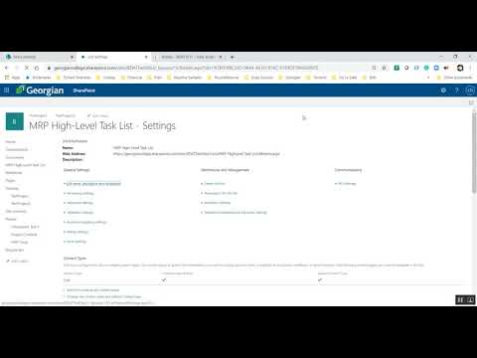](https://www.youtube.com/watch?v=UeLc0tZg2WU)

1. Go to Site Content link on the left side panel, select the *New drop-down*, then select App
2. Find the App named Tasks and select the button – you can search for this is search text box
3. Click on the Tasks App
4. You are presented with a text box to enter a name for your Task List
   1. Enter **MRP High-Level Task List**
5. Go to the List tab on your Task List toolbar at the top of the page
   1. Click List Settings
   2. Go to the bottom of the page and find the list of current columns in the Task List
   3. Click the Create Column link
6. Create a column named **Budgeted Hours**
   1. Use the Number data type
   2. Minimum is 0.5
   3. Maximum is 20
   4. The Default Value is 1
7. Create 2 *Calculated* Columns
   1. For both columns, you will select the Calculated Column radio button
   2. Column 1 is named **Start of Week**
      1. The formula for Start of Week is

* + 1. The data type is **Date and Time**
    2. The Data and Time format is **Date Only**
  1. Column 2 is named **End of Week**
     1. The formula for End of Week is

* + 1. The data type is **Date and Time**
    2. The Data and Time format is **Date Only**

1. Create 3 Views
   1. **Tasks This Week**
      1. Create this view based on the *Upcoming* v*iew*
      2. Add the Filter Criteria is
         * % Complete is not equal to 100
         * Start of Week is less than or equal to [Today]
         * AND
         * End of Week is greater than or equal to [Today]
   2. **Tasks Last Week**
      1. Create this view based on the *Task This Week view*
      2. Change the Filter Criteria to
         * Start of Week is less than or equal to [Today]-6
         * AND
         * End of Week is greater than or equal to [Today]-6
   3. **Tasks Next Week**
      1. Create this view based on the *Task Last Week view*
      2. Change the Filter Criteria to
         * Start of Week is less than or equal to [Today]+6
         * AND
         * End of Week is greater than or equal to [Today]+6
2. You may also want to create 3 Views for task related to you
   1. **My Tasks This Week**
      1. Create this view based on the *Tasks This Week* v*iew*
      2. Add the Filter Criteria
         * Assigned To is equal to [Me]
   2. **My Tasks Last Week**
      1. Create this view based on the *Tasks Last Week view*
      2. Add the Filter Criteria
         * Assigned To is equal to [Me]
   3. **My** **Tasks Next Week**
      1. Create this view based on the *Task Next Week view*
      2. Change the Filter Criteria
         * Assigned To is equal to [Me]

###### **Lesson Links**

* Video Tutorial, Chris Dyck - https://www.youtube.com/watch?v=UeLc0tZg2WU&list=PLWsYJ2ygHmWjOcw6xMQ5bmbYqrNxIEQbL&index=1
* 4 Quick Steps to set up SharePoint for Project Management -<https://www.brightwork.com/blog/4-quick-steps-to-set-up-sharepoint-for-project-management>
* Complete guide to filtering SharePoint lists by the current week - <http://blog.pentalogic.net/2012/09/complete-guide-to-filtering-sharepoint-lists-by-the-current-week/>
* Create and manage a project task list – SharePoint - <https://support.microsoft.com/en-us/office/create-and-manage-a-project-task-list-466ad207-46fd-4c77-9af1-41bc23cec21a>
* Examples of common formulas in lists - <https://support.microsoft.com/en-us/office/examples-of-common-formulas-in-lists-d81f5f21-2b4e-45ce-b170-bf7ebf6988b3>

# 002 Software Development Lifecycle (SDLC)

## SharePoint Task List - SDCL Timelines Add Tasks

Cross-Industry Standard Process for Data Mining or CRISP-DM is the industry standard for managing Data Analysis Projects. In this Course, we use a generalized version named SDLC.

[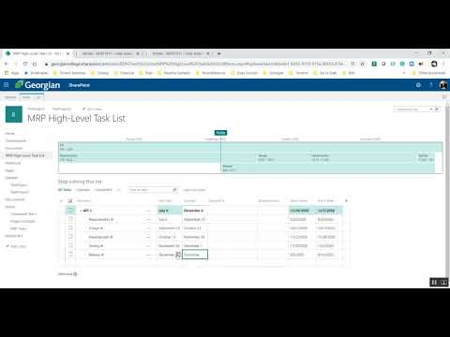](https://www.youtube.com/watch?v=04ZPwY0lJU0)

The key aspects of SDLC are:

1. **Planning** – Not part of the MRP
2. Requirements
3. Design
4. Development
5. Testing
6. Release
7. **Maintenance** – Not part of the MRP

The following video will give you a deeper explanation of the SDLC.

[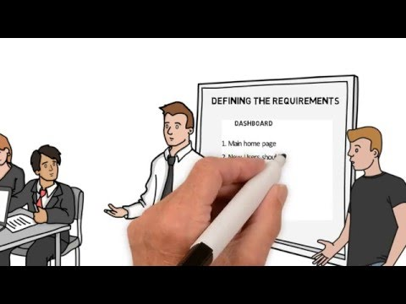](https://www.youtube.com/watch?v=i-QyW8D3ei0)

###### **Lesson Links**

* Video Tutorial, Chris Dyck - https://www.youtube.com/watch?v=04ZPwY0lJU0&list=PLWsYJ2ygHmWjOcw6xMQ5bmbYqrNxIEQbL&index=2

# 003 Microsoft Project

## SharePoint Task List - Integrate Microsoft Project

[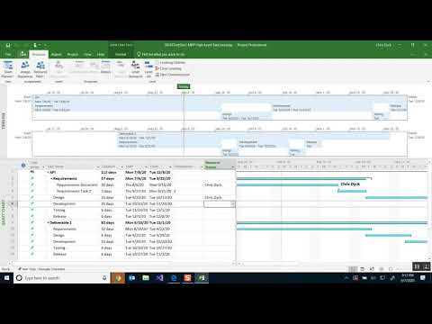](https://www.youtube.com/watch?v=LMm2QTjeSUw)

###### **Lesson Links**

* Video Tutorial, Chris Dyck - <https://www.youtube.com/watch?v=LMm2QTjeSUw&list=PLWsYJ2ygHmWjOcw6xMQ5bmbYqrNxIEQbL&index=3>

# 004 Microsoft Outlook

## SharePoint Task List - Connect Microsoft Outlook

[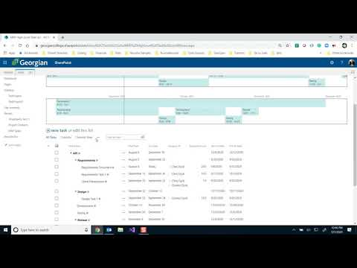](https://www.youtube.com/watch?v=DWUAd9un6Zk)

###### **Lesson Links**

* Video Tutorial, Chris Dyck - <https://www.youtube.com/watch?v=DWUAd9un6Zk&list=PLWsYJ2ygHmWjOcw6xMQ5bmbYqrNxIEQbL&index=4>

# 005 SharePoint Lists App for Timesheets

## SharePoint Setup Timesheets List

The Timesheets List will allow you to track the time your team spends on Tasks.

[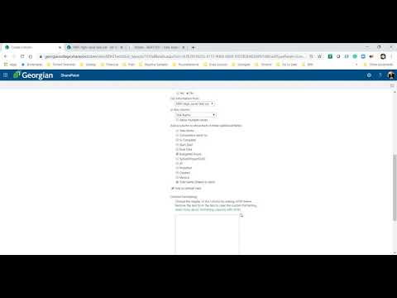](https://www.youtube.com/watch?v=3R_c-tQSFnQ)

##### **Install the Custom List for Timesheets**

* Go to Site Contents link on the left side panel, select the *New drop-down,* then select App
* Find the App named Custom List and select the button – you can search for this in the search text box
* Click on the Custom List app
* You are presented with a text box to enter a name for your Task List
  + Enter ***Timesheets***

##### **Change the List to display in Classic mode**

* Find the icon in the upper right corner of the screen
* Click on List Settings
* Click on Advanced Settings
  + Find – List experience
    - Change this value to **Classic experience**
* Save the settings by clicking on the Ok button at the bottom of the page

##### **Add Version Settings**

* Click on Version Settings
* Find Item Version History
  + Find – Create a version each time you edit an item in this list
    - Yes
  + Find – Keep the following number of versions
    - 50
* Save the settings by clicking on the Ok button at the bottom of the page

##### **Change Title Column to Calculated Value**

* If you are not in the List Settings page, find the List tab on the Timesheet toolbar
* Click on the List Settings button
* Find the column area of the List Settings page
* Click on the Title column
* Default Value
  + Calculated Value
* Save the settings by clicking on the Ok button at the bottom of the page

**Add Columns**

* Go back to List Settings
* Find the Column area
* Click on Create Column
  + The name is
    - **Deliverable**
  + The Column type is
    - Lookup
  + Description
    - This is the top- level summary task related to the deliverable you are working on
  + Require that this column contains information
    - Yes
  + Get information from
    - Select MRP High- Level Task List
  + In this column
    - Select Task Name
  + Save the settings by clicking on the Ok button at the bottom of the page
* Click on Create Column
  + The name is
    - **Project Phase**
  + The Column type is
    - Lookup
  + Description
    - This is the SDLC Project Phase for the deliverable you are working on
  + Require that this column contains information
    - Yes
  + Get information from
    - Select MRP High-Level Task List
  + In this column
    - Select Task Name
  + Save the settings by clicking on the Ok button at the bottom of the page
* Click on Create Column
  + The name is
    - **Task**
  + The Column type is
    - Lookup
  + Description
    - This is the task related to the deliverable you are working on
  + Require that this column contains information
    - Yes
  + Get information from
    - Select MRP High-Level Task List
  + In this column
    - Select Task Name
  + Add a column to show each of these additional fields
    - Select Budgeted Hours and Task name (linked to item)
  + Save the settings by clicking on the Ok button at the bottom of the page
* Click on Create Column
  + The name is
    - **Assigned To**
  + The Column type is
    - Person or Group
  + Description
    - This is the person who performed the task
  + Require that this column contains information
    - Yes
  + Choose from
    - All Users
  + Show Field
    - Name (with Presence)
  + Save the settings by clicking on the Ok button at the bottom of the page
* Click on Create Column
  + The name is
    - **Hours**
  + The Column type is
    - Number (1, 1.0, 100)
  + Require that this column contains information
    - Yes
  + Specify a minimum and maximum allowed value:
    - Min: 0.25 Max: 10
  + Number of decimal places
    - 2
  + Default Value
    - 1
  + Save the settings by clicking on the Ok button at the bottom of the page
* Click on Create Column
  + The name is
    - **Task Date**
  + The Column type is
    - Date and Time
  + Require that this column contains information
    - Yes
  + Date and Time Format
    - Date Only
  + Default Value
    - Today’s Date
  + Save the settings by clicking on the Ok button at the bottom of the page
* Click on Create Column
  + The name is
    - **Comments**
  + The Column type is
    - Multiple lines of text
  + Require that this column contains information
    - No
  + Number of lines for editing
    - 6
  + Specify the type of text to allow
    - Enhanced rich text (Rich text with pictures, tables, and hyperlinks)
  + Append Changes to Existing Text
    - Yes
  + Save the settings by clicking on the Ok button at the bottom of the page

###### **Lesson Links**

* Video Tutorial, Chris Dyck - <https://www.youtube.com/watch?v=3R_c-tQSFnQ&list=PLWsYJ2ygHmWjOcw6xMQ5bmbYqrNxIEQbL&index=5>

# 006 SharePoint Lists App for Timesheets

## SharePoint Create View

[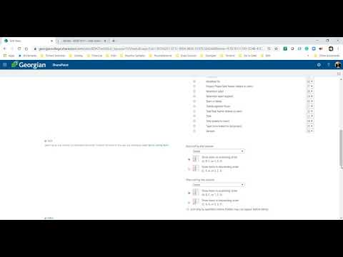](https://www.youtube.com/watch?v=VKv9Kyd8hSU)

##### **Add Calculated Columns for Grouping and Filters**

* Click on Create Column
  + The name of the column is
    - **Start of Week**
  + The Column Type is
    - Calculated (Calculation based on other columns)
  + Formula
  + The data type returned from this formula is
    - Date and Time
  + Date and Time format
    - Date Only
  + Save the settings by clicking on the Ok button at the bottom of the page
* Click on Create Column
  + The name of the column is
    - **End of Task**
  + The Column Type is
    - Calculated (Calculation based on other columns)
  + Formula
  + The data type returned from this formula is
    - Date and Time
  + Date and Time format
    - Date Only
  + Save the settings by clicking on the Ok button at the bottom of the page

##### **Create the view – Grouped By Assigned To**

* Go to the List Settings page for the Timesheet
* Find the Views area
* Click Create View
* Choose View Type Standard View
* View Name
  + Grouped By Assigned To
* Select the following columns
  + Title (linked to item with edit menu)
  + Deliverable
  + Project Phase
  + Task
  + Hours
* Group By
  + Assigned To
  + Then By
    - Deliverable
  + By Default, show grouping
    - Expanded
* Totals
  + Hours
    - Sum

##### **Create View – Grouped By Week**

* Go to the List Settings page for the Timesheet
* Find the Views area
* Click Create View
* Choose View Type Standard View
* View Name
  + Grouped by Week
* Select the following columns
  + Title (linked to item with edit menu)
  + Deliverable
  + Project Phase
  + Task
  + Hours
* Group By
  + Start of Week
  + Then by
    - Assigned To
  + By default, show grouping
    - Expanded
* Totals
  + Hours
    - Sum

###### **Lesson Links**

* Video Tutorial, Chris Dyck - <https://www.youtube.com/watch?v=VKv9Kyd8hSU&list=PLWsYJ2ygHmWjOcw6xMQ5bmbYqrNxIEQbL&index=6>

# 007 SharePoint Issue Tracker App for Action Items

## SharePoint Action Items

[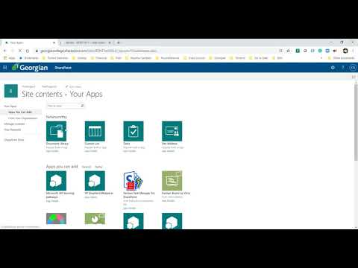](https://www.youtube.com/watch?v=B50H2DNuzV8)

##### **Install the Issue Tracker App for Action Items**

* Go to Site Contents link on the left side panel, select the *New drop-down*, then select App
* Find the App named Issue Tracker and select the button – you can search for this in the search box
* Click on the Issue Tracker app
* You are presented with a text box to enter a name for your Task List
  + Enter ***Action Items***

##### **Change the List to display in Classic mode**

* Find the  icon in the upper right corner of the screen
* Click on List Settings
* Click on Advanced Settings
  + Find – List experience
    - Change this value to **Classic experience**
* Save the settings by clicking on the Ok button at the bottom of the page

##### **Version Settings**

* The Issue Tracker App automatically tracks versions of items in the list
* To view the Version History, click on the three dots button on a list item, select Version History

##### **Advanced Settings**

* Click on Advanced Settings
* Find E-mail Notification
* Send e-mail when ownership is assigned?
  + Yes
* This will turn on the function that sends an email notification when a person is assigned to an item
* Save the settings by clicking on the Ok button at the bottom of the page

**Add Columns**

* Go back to List Settings
* Find the Column area
* Click on Create Column
  + The name is
    - **Related Task**
  + The Column Type is
    - Lookup
  + Description
    - This is the top-level summary task related to the deliverable you are working on
  + Require that this column contains information
    - No
  + Get information from
    - Select MRP High-Level Task List
  + Allow multiple values
    - Yes
  + In this column
    - Select Task Name
  + Save the settings by clicking on the Ok button at the bottom of the page

###### **Lesson Links**

* Video Tutorial, Chris Dyck - <https://www.youtube.com/watch?v=B50H2DNuzV8&list=PLWsYJ2ygHmWjOcw6xMQ5bmbYqrNxIEQbL&index=7>

# 008.01 Minutes of Meeting

## SharePoint Minutes of Meeting (MOM)

* When the meeting was conducted
* Who was present for the meeting
* How the meeting was conducted (Online Conference In-person or other)
* Where the meeting was conducted
* What Actions Items were covered in the meeting
  + What were the outcomes of Actions Items and the next steps
* Approvals of Previous and Current Meeting

The following video explains how to take effective MOM for your project:

[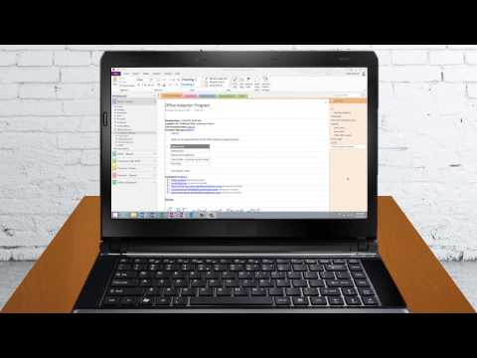](https://www.youtube.com/watch?v=whHXp2ae6jc)

# 008.02 SharePoint List App for Minutes of Meetings

## SharePoint Setup Minutes of Meeting

The Minutes of Meetings List will allow you to track the time your team spends on Tasks.

[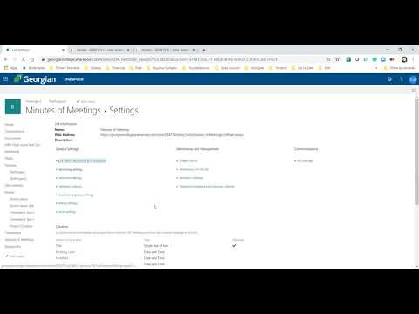](https://www.youtube.com/watch?v=zcViCCF1w5Q)

**Install The list App for Minutes of Meetings**

* Go to Site Contents link on the left side panel, select the *New drop-down*, then select App
* Find the App named Custom List and select the button – you can search for this in the search box
* Click on the Custom List app
* You are presented with a text box to enter a name for your Task List
  + Enter ***Minutes of Meetings***

##### **Change the List to display in Classic mode**

* Find the  icon in the upper right corner of the screen
* Click on List Settings
* Click on Advanced Settings
  + Find – List experience
    - Change this value to **Classic experience**
* Save the settings by clicking on the Ok button at the bottom of the page

##### **Add Version Settings**

* Click on Version Settings
* Find Item Version History
* Find – Create a version each time you edit an item in the list
  + Yes
* Find – Keep the following number of versions
  + 50
* Save the settings by clicking on the Ok button at the bottom of the page
* To view the Version History, click on the three horizontal dots button on a list item, select Version History

##### **Change Title Column to Calculate Value**

* If you are not on the List settings page, find the List tab on the Minutes of Meeting toolbar
* Click on the List Settings button
* Find the Columns area of the List Settings page
* Click on the Title column
* Default Value
  + Calculated Value
* Save the settings by clicking on the Ok button at the bottom of the page

##### **Add Columns**

* Go back to List Settings
* Find the Columns area
* Click on Create Column
  + The name is
    - **Meeting Date**
  + The Column type is
    - Date and Time
  + Description
    - Choose the date and time when the meeting occurred
  + Require that this column contains information
    - No
  + Date and Time Format
    - Date & Time
  + Display Format
    - Standard
  + Default Value
    - Today’s Date
  + Save the settings by clicking on the Ok button at the bottom of the page
* Click on Create Column
  + The name is
    - **Description**
  + The Column type is
    - Multiple Lines of text
  + Description
    - Add a description for your meeting, if needed
  + Require that this column contains information
    - No
  + Specify the type of text to allow
    - Plaint Text
  + Save the settings by clicking on the Ok button at the bottom of the page
* Click on Create Column
  + The name is
    - **Location**
  + The Column type is
    - Multiple lines of text
  + Description
    - The Building, Room, Online Conference URL, Telephone, If was an Online meeting paste the URL for the meeting here.
  + Require that this column contains information
    - Yes
  + Number of lines for editing
    - 2
  + Specify the type of text to allow
    - Plaint Text
  + Save the settings by clicking on the Ok button at the bottom of the page
* Click on Create Column
  + The name is
    - **Action Items**
  + The Column type is
    - Lookup
  + Description
    - Select the Actions Items that were discussed in the meeting
  + Require that this column contains information
    - No
  + Get Information from
    - Select Actions Items
  + In this column
    - Select Title
  + Save the settings by clicking on the Ok button at the bottom of the page
* Click on Create Column
  + The name is
    - **Attendees**
  + The Column type is
    - Person of Group
  + Description
    - These are the people who attended the meeting
  + Require that this column contains information
    - No
      * This is optional but must have attended to be valid
  + Allow multiple selections
    - Yes
  + Choose from
    - All Users
  + Show Field
    - Name (with Presence)
  + Save the settings by clicking on the Ok button at the bottom of the page
* Click on Create Column
  + The name is
    - **Announcements**
  + The Column type is
    - Multiple lines of text
  + Description
    - This section of the minutes reports on any announcements made by participants or those who sent their apologies, including proposed agenda items for the next meeting.
  + Require that this column contains information
    - No
  + Number of lines for editing
    - 6
  + Specify the type of text to allow
    - Plain text
  + Save the settings by clicking on the Ok button at the bottom of the page
* Click on Create Column
  + The name is
    - **Approval of Previous Minutes**
  + The Column type is
    - Choice (menu to choose from)
  + Description
    - Choose a person in the group to approve the minutes of the previous meeting. This person must log in to Minutes of the Meeting and approve this using their own user credentials
  + Require that this column contains information
    - No
  + Type each choice on a separate line
    - (1) Awaiting Approval
    - (2) Not Approval
    - (3) Approved
  + Display choices using
    - Drop-Down Menu
  + Default Value
    - (1) Awaiting Approval
  + Save the settings by clicking on the Ok button at the bottom of the page
* Click on Create Column
  + The name is
    - **Next Meeting**
  + The Column type is
    - Lookup
  + Description
    - Select a Task that is reserved for Meeting times
  + Require that this column contains information
    - No
  + Get Information from
    - Select MRP High-Level Task List
  + In this column
    - Select Task Name
  + Add a column to show each of these additional fields
    - ID
    - Start Date
  + Save the settings by clicking on the Ok button at the bottom of the page
* Click on Create Column
  + The name is
    - **Approval Signature**
  + The Column type is
    - Yes/No (check box)
  + Description
    - A member of your team should approve the minutes of the meeting before the start of the next meeting. This person may be your sponsor of the Team Lead.
  + Require that this column contains information
    - No
  + Default Value
    - No
  + Save the settings by clicking on the Ok button at the bottom of the page

##### **Create Views**

###### **Create the View** – Not Approved

* Go to the List Settings page for Minutes of Meetings
* Find the Views area
* Click the View Type Standard View
* View Name
  + **Not Approved**
* Select the following columns
  + Title (linked to item with edit menu)
  + Meeting Date
  + Action Items

###### **Create the View** – Calendar

* Go to the List Settings page for Minutes of Meetings
* Find the Views area
* Click Create View
* Choose View Type Standard View
* View Name
  + **Calendar**
* Time Interval
  + Begin
    - Meeting Date
  + End
    - Meeting Date
* Calendar Columns
  + Month View Title
    - Title
  + Week View Title
    - Title
  + Day View Title
    - Title
* Calendar Columns
  + Month

###### **Lesson Links**

* Video Tutorial, Chris Dyck - https://www.youtube.com/watch?v=zcViCCF1w5Q&list=PLWsYJ2ygHmWjOcw6xMQ5bmbYqrNxIEQbL&index=8
* Elements of Meeting Minutes - <http://www.free-management-ebooks.com/faqmt/minutes-02.htm>
* Project Meeting Minutes – 12 Sample - <http://www.free-management-ebooks.com/faqmt/minutes-02.htm>

# 009.00 SharePoint Excel Dashboard

## SharePoint Setup Dashboard

[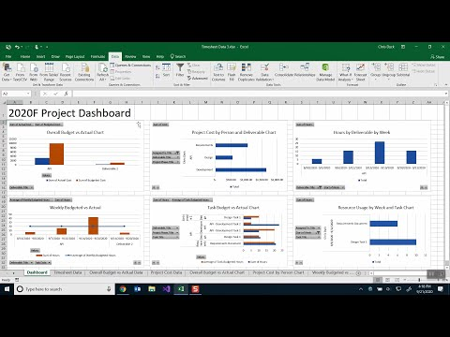](https://www.youtube.com/watch?v=pUh6DobVQJc)

###### **Lesson Links**

* Video Tutorial, Chris Dyck - https://www.youtube.com/watch?v=pUh6DobVQJc&list=PLWsYJ2ygHmWjOcw6xMQ5bmbYqrNxIEQbL&index=9

# 010.00 SharePoint Project Dashboard Page

## SharePoint Setup Project Dashboard Page

[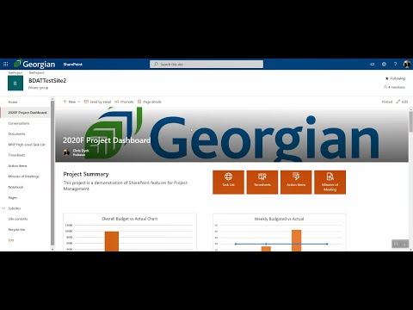](https://www.youtube.com/watch?v=d_TuQGV8HAA)

###### **Lesson Links**

* Video Tutorial, Chris Dyck - https://www.youtube.com/watch?v=d_TuQGV8HAA&list=PLWsYJ2ygHmWjOcw6xMQ5bmbYqrNxIEQbL&index=10